Equipment and materials for high-temperature ceramic welding
Units for high-temperature ceramic welding, output is up to 120 kg/hour. Ceramic powders for repair of dinas, chamotte, chromomagnesite and other linings of coking, glass-boiling, metallurgical and other furnaces. The repair is made without stopping and cooling furnaces.
CERAMIC WELDING ENABLES REPAIRS
OF HIGH TEMPERATURES LININGS
FOR OVENS WITHOUT ANY STOPS

SAFETY,
LONG SERVICE LIFE,
EFFICIENCY
OF YOUR OVENS
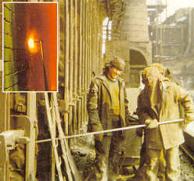 | 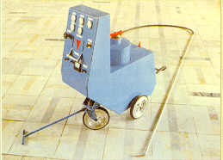  we offer:  - Equipment delivery  - Powder repair delivery  - Repair and inspection of lining  - Repair of equipment  - Personal training
  POWDERS FOR REPAIR WORKS
  MARK | PURPOSE
  “Soyuz” | For repair and maintenance of coke ovens and batteries and glassmaking furnaces. Composition and thermal properties of welding on mass are like silica refractory.
  “C” | Repair and maintenance of magnesite (general) lining and ladles. For lining and repair of steel casting ladles.
  “T” | For lining and repair of steel casting ladles and glassmaking furnaces.
  “2S” | For lining, repair and design modifications of ovens. A very high adhesion degree. Two layer variant of repair.
  “MK” | For repair and reconstruction of glass making ovens, steel smelting ladles which lining consist of 70% AL₂O₃
  REPAIR EQUIPMENT
  Performances | Model
  Performances | UKN-50 | UKN-120
  Lance length, m | 2…4 | 2…9
  Range of capacity regulation, kg/hour | 20…50 | 30…120
  Max. powder change, kg | 30 | 50
  Distance of mixture feeding, m | to 20 | to 50
  Dimension BxLxH, mm | 570x1100x1300 | 570x1100x1300
  Mass, kg | 100 | 130
  Team of repair workers | 3 | 3

